**Computer Networks COE 351**

# Final Project

Contents

Final Project 1

1. IP's for the routers 3

why we used that? 4

2. New areas ip addresses 5

Area 47 5

Area 48 5

Area 49 6

Area 50 6

3. For the LAN's: 6

3.1 LAN in area 1 should have around 60000 users. 7

3.2 Area 2 should contain two VLANs: 7

3.3 LAN in area 3 should have around 8000 users. 8

3.4 Lan in area 4 should have 500 users. 9

Address table after add all interfaces 10

OSPF routing protocol 12

R12 Show ospf neighbor 14

R17 Show ospf neighbor 14

R14 Show ospf neighbor 15

R12 Show ip ospf database 15

R14 Show ip ospf database 16

R17 Show ip ospf database 17

R14 Show ip ospf database summary 18

R17 Show ip ospf database summary 20

R12 Show ip ospf database summary 24

cost from Router 14 to Router 17 27

show ip ospf interface brief 29

Shortest path from Router 14 to Router 17 31

Cost from Router 14 to Router 17 31

Router 11 37

Router 12 40

Router 2 42

Router 13 45

Router 4 47

Router 17 49

Router 16 52

Router 15 54

Router 14 56

Figure 1 Topology 4

Figure 2 Topology with added addresses 5

Figure 3 R12 Show ospf neighbor 16

Figure 4 R17 Show ospf neighbor 16

Figure 5 R14 Show ospf neighbor 17

Figure 6 R12 Show ip ospf database 18

Figure 7 R14 Show ip ospf database 19

Figure 8 R17 Show ip ospf database 20

Figure 9 R14 Show ip ospf database summary 21

Figure 10 R14 Show ip ospf database summary 22

Figure 11 R17 Show ip ospf database summary 22

Figure 12 R17 Show ip ospf database summary 24

Figure 13 R17 Show ip ospf database summary 25

Figure 14 R12 Show ip ospf database summary 26

Figure 15 R12 Show ip ospf database summary 27

Figure 16 R12 Show ip ospf database summary 28

Figure 17 topology 30

Figure 18 optimal path from R14 to R17 30

Figure 19 Router 14 show ip ospf interface brief 31

Figure 20 Router 12 show ip ospf interface brief 31

Figure 21 Router 2 show ip ospf interface brief 31

Figure 22 Router 17 show ip ospf interface brief 31

Figure 23 Router 11 show ip ospf interface brief 32

Figure 24 Router 13 show ip ospf interface brief 32

Figure 25 cost at each path 32

Figure 26 Router 12 show ip route ospf 33

Figure 27 shortest path cost selection 34

Figure 28 Router 2 show ip ospf 35

Figure 29 Router 12 show ip ospf 36

Figure 30 Router 14 show ip ospf 37

Figure 31 Router 11 show ip ospf 38

Figure 32 Router 13 show ip ospf 39

Table 1 addresssing table 5

Table 2 area table 6

Table 3 address range in each area 7

Table 4 area 47 7

Table 5 area 48 7

Table 6 area 49 8

Table 7 area 50 8

Table 8 lan in area 47 9

Table 9 lan in area 48 10

Table 10 lan in area 49 11

Table 11 lan in area 50 11

Table 12 whole lans in each area 12

Table 13 whole addressing table 13

Table 14 ospf configuration in each router 14

Table 15 area names and addresses 29

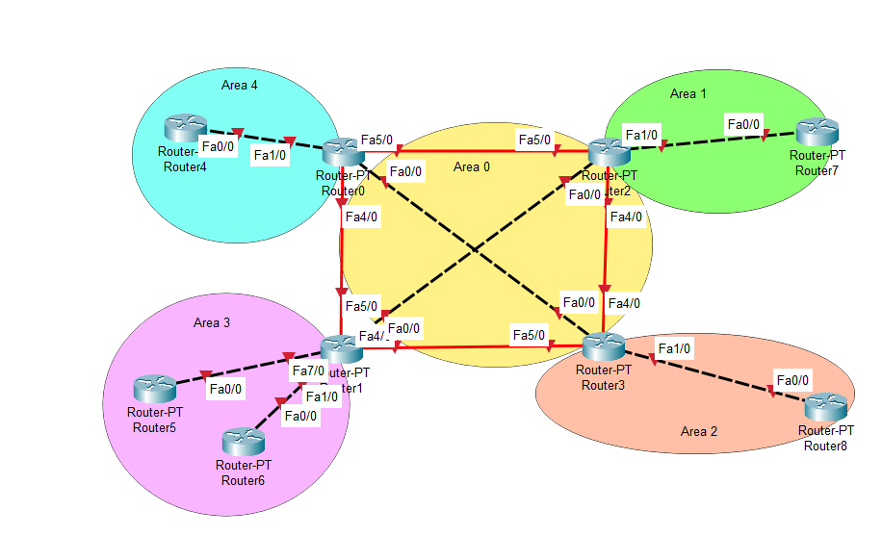

Figure 1 Topology

**You need to do the followed:**

1. **Choose the IP's for the routers and use subnet 30, and write why we used that? (write the IP addresses next to the interface).**

# IP's for the routers

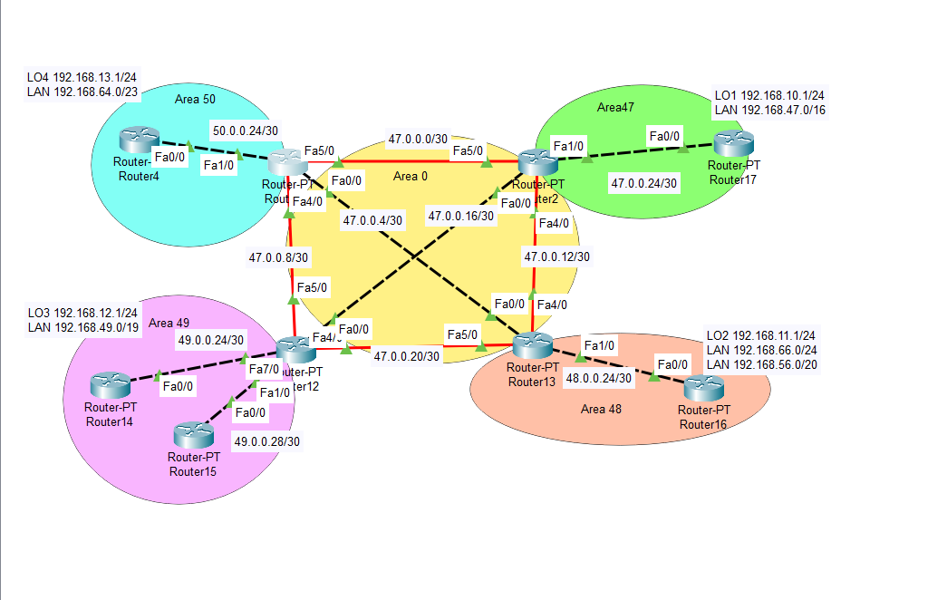

Figure 2 Topology with added addresses

Student id : 3912028**47**

x = 47

Table 1 addresssing table

|  |  |  |
| --- | --- | --- |
| Router 11 |  |  |
| Fa5/0 | 47.0.0.1 | 255.255.255.252 |
| Fa0/0 | 47.0.0.5 | 255.255.255.252 |
| F4/0 | 47.0.0.9 | 255.255.255.252 |
| Router 12 |  |  |
| Fa5/0 | 47.0.0.10 | 255.255.255.252 |
| Fa4/0 | 47.0.0.21 | 255.255.255.252 |
| Fa0/0 | 47.0.0.17 | 255.255.255.252 |
| Router 2 |  |  |
| Fa5/0 | 47.0.0.2 | 255.255.255.252 |
| Fa0/0 | 47.0.0.18 | 255.255.255.252 |
| Fa4/0 | 47.0.0.13 | 255.255.255.252 |
| Fa1/0 | 47.0.0.26 | 255.255.255.252 |
| Router 13 |  |  |
| Fa4/0 | 47.0.0.14 | 255.255.255.252 |
| Fa0/0 | 47.0.0.6 | 255.255.255.252 |
| Fa5/0 | 47.0.0.22 | 255.255.255.252 |

# why we used that?

Table 2 area table

|  |  |  |  |
| --- | --- | --- | --- |
| 47.0.0.0 /30 | 47.0.0.1 | 47.0.0.2 | 255.255.255.252 |
| 47.0.0.4/30 | 47.0.0.5 | 47.0.0.6 | 255.255.255.252 |
| 47.0.0.8/30 | 47.0.0.9 | 47.0.0.10 | 255.255.255.252 |
| 47.0.0.12/30 | 47.0.0.13 | 47.0.0.14 | 255.255.255.252 |
| 47.0.0.16/30 | 47.0.0.17 | 47.0.0.18 | 255.255.255.252 |
| 47.0.0.20/30 | 47.0.0.21 | 47.0.0.22 | 255.255.255.252 |

1. **Area number should match of X except the one in area 0. EX if IP is 10.10.0.0 area should be area 10. For LANs use 192.168.X.0 change X to be the same as your area ID. on area 2, the second VLAN X will be (area ID + 4).**

# New areas ip addresses

Table 3 address range in each area

|  |  |  |
| --- | --- | --- |
| Area 0 | | |
|  | | |
| Area 1 = > Area 47 | | |
| **Area Subnet** | **Start IP** | **second IP** |
| 47.0.0.24/30 | 47.0.0.25 | 47.0.0.26 |
|  | | |
| Area 2 = > Area 48 | | |
| **Area Subnet** | **Start IP** | **second IP** |
| 48.0.0.24/30 | 48.0.0.25 | 48.0.0.26 |
| Area 3 = > Area 49 | | |
| **Area Subnet** | **Start IP** | **second IP** |
| 49.0.0.24/30 | 49.0.0.25 | 49.0.0.26 |
| 49.0.0.28/30 | 49.0.0.29 | 49.0.0.30 |
| Area 4 = > Area 50 | | |
| **Area Subnet** | **Start IP** | **second IP** |
| 50.0.0.24/30 | 50.0.0.25 | 50.0.0.26 |

# Area 47

Table 4 area 47

|  |  |  |
| --- | --- | --- |
| Area 47 | | |
| **Router 2** |  |  |
| Fa1/0 | 47.0.0.26 | 255.255.255.252 |
| **Router 17** |  |  |
| Fa0/0 | 47.0.0.25 | 255.255.255.252 |

# Area 48

Table 5 area 48

|  |  |  |
| --- | --- | --- |
| Area 48 | | |
| **Router 13** |  |  |
| Fa1/0 | 48.0.0.25 | 255.255.255.252 |
| **Router 16** |  |  |
| Fa0/0 | 48.0.0.26 | 255.255.255.252 |

# Area 49

Table 6 area 49

|  |  |  |
| --- | --- | --- |
| Area 49 | | |
| **Router 14** |  |  |
| Fa0/0 | 49.0.0.26 | 255.255.255.252 |
| **Router 15** |  |  |
| Fa0/0 | 49.0.0.29 | 255.255.255.252 |
| **Router 12** |  |  |
| Fa1/0 | 49.0.0.25 | 255.255.255.252 |
| Fa7/0 | 49.0.0.30 | 255.255.255.252 |

# Area 50

Table 7 area 50

|  |  |  |
| --- | --- | --- |
| Area 50 | | |
| **Router 11** |  |  |
| Fa1/0 | 50.0.0.25 | 255.255.255.252 |
| **Router 4** | **Area 50** |  |
| Fa0/0 | 50.0.0.26 | 255.255.255.252 |

# For the LAN's:

**1. LAN in area 3 should have around 8000 users. (chose the closest number to 8000 users but not less than 8000 users).**

**2. Lan in area 4 should have 500 users.**

**3. Area 2 should contain two VLANs:**

**1. VLAN 1 should be class C**

**2. VLAN 2 should have 3000 users.**

**4. LAN in area 1 should have around 60000 users.**

**4. Each LAN and VLAN should have DHCP service.**

**For LAN in each area**

# LAN in area 1 should have around 60000 users.

LAN : 192.168.47.0/16 = 65536 users

Enable DHCP service

Start 192.168.0.1 End 192.168.255.254

Table 8 lan in area 47

|  |
| --- |
| Area 47 |
| Router 17 |
| ! ip dhcp pool router17 network 192.168.74.0 255.255.0.0 default-router 192.168.0.1 |

# Area 2 should contain two VLANs:

**1. VLAN 1 should be class C**

**2. VLAN 2 should have 3000 users.**

LAN 192.168.66.0/ 24= class C

Enable DHCP service

Start 192.168.66.1 End 192.168.66.254

LAN 192.168.56.0/ 20= 4094 users

Enable DHCP service

Start 192.168.16.1 End 192.168.31.254

Table 9 lan in area 48

|  |
| --- |
| Area 48 |
| Router 16 |
| ! ip dhcp pool router16 network 192.168.66.0 255.255.255.0 default-router 192.168.66.1  !  ip dhcp pool router16-2 network 192.168.56.0 255.255.240.0 default-router 192.168.16.1 |

# LAN in area 3 should have around 8000 users.

**(chose the closest number to 8000 users but not less than 8000 users).**

LAN 192.168.31.0/24 class C

Enable DHCP service

Start 192.168.31.1 end 192.168.31.254

LAN 192.168.49.0/19 = 8,192 users

Enable DHCP service

Start 192.168.32.1 end 192.168.63.254

Table 10 lan in area 49

|  |
| --- |
| Area 49 |
| Router 14 |
| ! ip dhcp pool router14 network 192.168.49.0 255.255.224.0 default-router 192.168.32.1  !  ! ip dhcp pool router14-2 network 192.168.31.0 255.255.255.0 default-router 192.168.31.1  ! |

# Lan in area 4 should have 500 users.

LAN : 192.168.64.0/23= 512 users

Enable DHCP service

End 192.168.65.254

Table 11 lan in area 50

|  |
| --- |
| Area 50 |
| Router 4 |
| ! ip dhcp pool router4 network 192.168.49.0 255.255.254.0 default-router 192.168.64.1 |

Table 12 whole lans in each area

|  |  |  |  |  |  |  |  |  |  |  |  |  |
| --- | --- | --- | --- | --- | --- | --- | --- | --- | --- | --- | --- | --- |
| Area 47 | | | | | | | | | | | | |
| LAN : 192.168.47.0/16 = 65536 users | | | | | | | | | | | | |
| Start | | | | 192.168.0.1 | | | | End | | | | 192.168.255.254 |
|  | | | | | | | | | | | | |
| Area 48 | | | | | | | | | | | | |
| LAN 192.168.66.0/ 24= class C | | | | | | | | | | | | |
| LAN 192.168.56.0/ 20= 4094 users | | | | | | | | | | | | |
| Start | | | 192.168.16.1 | | | | End | | | | 192.168.31.254 | |
|  | | | | | | | | | | | | |
| Area 49 | | | | | | | | | | | | |
| LAN 192.168.31.0/24 class C | | | | | | | | | | | | |
| LAN 192.168.49.0/19 = 8,192 users | | | | | | | | | | | | |
| Start | 192.168.32.1 | | | | end | | | | 192.168.63.254 | | | |
|  | | | | | | | | | | | | |
| Area 50 | | | | | | | | | | | | |
| LAN : 192.168.64.0/23= 512 users | | | | | | | | | | | | |
| Start | | 192.168.64.1 | | | | End | | | | 192.168.65.254 | | |
|  | | | | | | | | | | | | |

# Address table after add all interfaces

Table 13 whole addressing table

|  |  |  |
| --- | --- | --- |
| Router 11 |  |  |
| Fa5/0 | 47.0.0.1 | 255.255.255.252 |
| Fa0/0 | 47.0.0.5 | 255.255.255.252 |
| F4/0 | 47.0.0.9 | 255.255.255.252 |
| Fa1/0 | 50.0.0.25 | 255.255.255.252 |
| Router 12 |  |  |
| Fa5/0 | 47.0.0.10 | 255.255.255.252 |
| Fa4/0 | 47.0.0.21 | 255.255.255.252 |
| Fa0/0 | 47.0.0.17 | 255.255.255.252 |
| Fa1/0 | 49.0.0.25 | 255.255.255.252 |
| Fa7/0 | 49.0.0.30 | 255.255.255.252 |
| Router 2 |  |  |
| Fa5/0 | 47.0.0.2 | 255.255.255.252 |
| Fa0/0 | 47.0.0.18 | 255.255.255.252 |
| Fa4/0 | 47.0.0.13 | 255.255.255.252 |
| Fa1/0 | 47.0.0.26 | 255.255.255.252 |
| Router 13 |  |  |
| Fa4/0 | 47.0.0.14 | 255.255.255.252 |
| Fa0/0 | 47.0.0.6 | 255.255.255.252 |
| Fa5/0 | 47.0.0.22 | 255.255.255.252 |
| Fa1/0 | 48.0.0.25 | 255.255.255.252 |
| Router 4 | Area 50 |  |
| Fa0/0 | 50.0.0.26 | 255.255.255.252 |
| LO4 | 192.168.13.0 | 255.255.255.0 |
| LAN | 192.168.64.0 | 255.255.254.0 |
| Router 14 | Area 49 |  |
| Fa0/0 | 49.0.0.26 | 255.255.255.252 |
|  |  |  |
| LO3 | 192.168.12.0 | 255.255.255.0 |
| Router 15 | Area 49 |  |
| Fa0/0 | 49.0.0.29 | 255.255.255.252 |
| LAN | 192.168.49.0 | 255.255.224.0 |
| Router 17 | Area 47 |  |
| Fa0/0 | 47.0.0.25 | 255.255.255.252 |
| LO1 | 192.168.10.0 | 255.255.255.0 |
| LAN | 192.168.47.0 | 255.255.0.0 |
| Router 16 | Area 48 |  |
| Fa0/0 | 48.0.0.26 | 255.255.255.252 |
| LO2 | 192.168.11.0 | 255.255.255.0 |
| LAN | 192.168.66.0 | 255.255.255.0 |
| LAN | 192.168.56.0 | 255.255.240.0 |

# OSPF routing protocol

1. **Use OSPF routing protocol with the areas shown on the figure. (copy the commands on your report)**

Table 14 ospf configuration in each router

|  |
| --- |
| Router 11  router ospf 1  router-id 11.11.11.11  log-adjacency-changes  network 47.0.0.0 0.0.0.3 area 0  network 47.0.0.4 0.0.0.3 area 0  network 47.0.0.8 0.0.0.3 area 0  network 50.0.0.24 0.0.0.3 area 50  ! |
| Router 2  !  router ospf 1  router-id 2.2.2.2  log-adjacency-changes  network 47.0.0.0 0.0.0.3 area 0  network 47.0.0.12 0.0.0.3 area 0  network 47.0.0.16 0.0.0.3 area 0  network 47.0.0.24 0.0.0.3 area 47  ! |
| Router 12  !  router ospf 1  router-id 12.12.12.12  log-adjacency-changes  network 47.0.0.8 0.0.0.3 area 0  network 47.0.0.16 0.0.0.3 area 0  network 47.0.0.20 0.0.0.3 area 0  network 49.0.0.24 0.0.0.3 area 49  network 49.0.0.28 0.0.0.3 area 49  ! |
| Router 13  !  router ospf 1  router-id 13.13.13.13  log-adjacency-changes  network 47.0.0.12 0.0.0.3 area 0  network 47.0.0.4 0.0.0.3 area 0  network 47.0.0.20 0.0.0.3 area 0  network 48.0.0.24 0.0.0.3 area 48  ! |

|  |
| --- |
| Router 4  !  router ospf 1  log-adjacency-changes  network 50.0.0.24 0.0.0.3 area 50 |
| Router 17  router ospf 1  log-adjacency-changes  network 47.0.0.24 0.0.0.3 area 47  ! |
| Router 16  !  router ospf 1  log-adjacency-changes  network 48.0.0.24 0.0.0.3 area 48  ! |
| Router 14  !  router ospf 1  log-adjacency-changes  network 49.0.0.24 0.0.0.3 area 49  ! |
|  |
| Router 15  !  router ospf 1  log-adjacency-changes  network 49.0.0.28 0.0.0.3 area 49  ! |

**6. Use show command to show the next for router 12, router 17, router 14:**

**- neighbors**

# R12 Show ospf neighbor

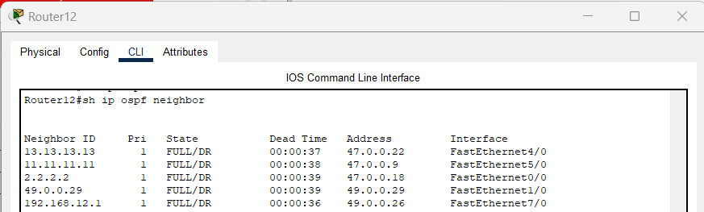

Figure 3 R12 Show ospf neighbor

# R17 Show ospf neighbor

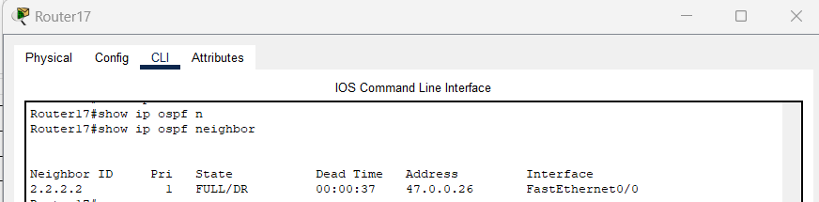

Figure 4 R17 Show ospf neighbor

# R14 Show ospf neighbor

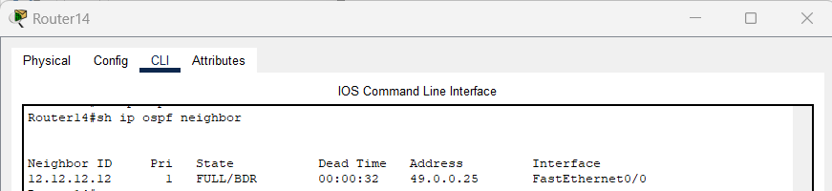

Figure 5 R14 Show ospf neighbor

**- database**

# R12 Show ip ospf database

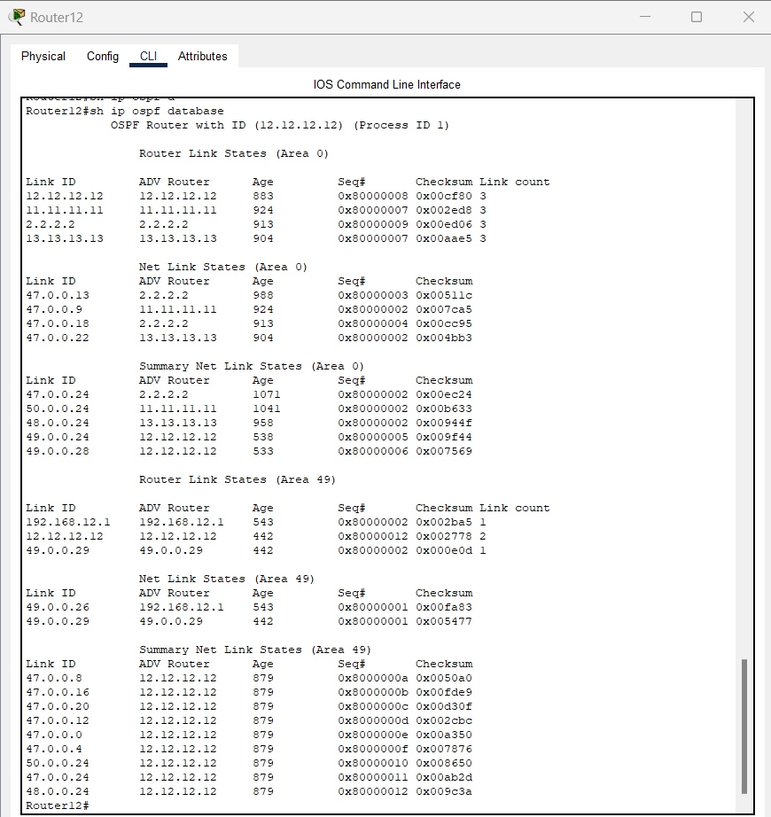

Figure 6 R12 Show ip ospf database

# R14 Show ip ospf database

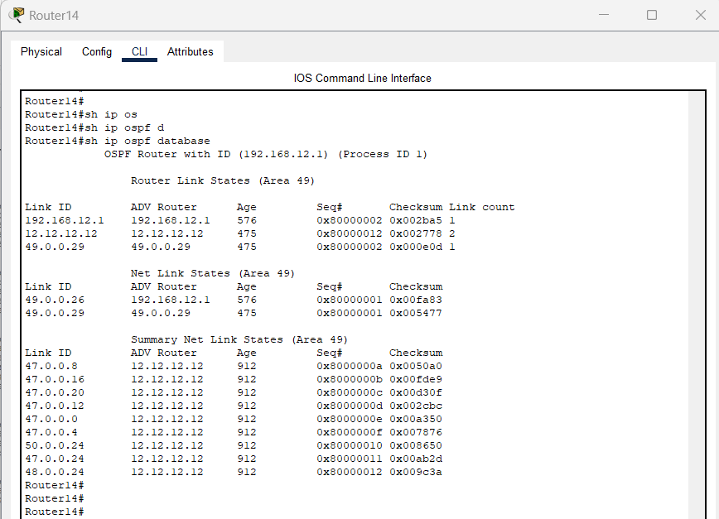

Figure 7 R14 Show ip ospf database

# R17 Show ip ospf database

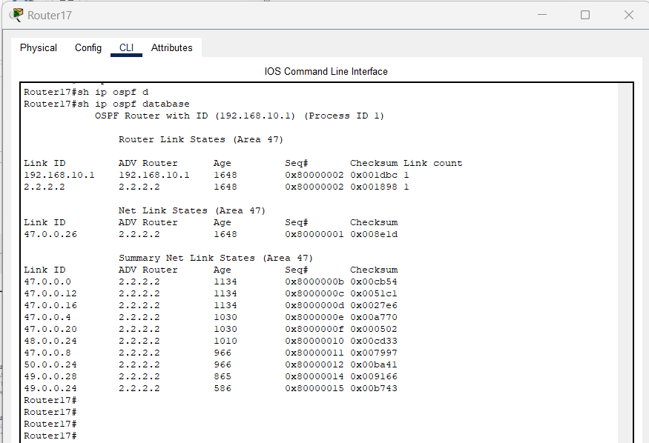

Figure 8 R17 Show ip ospf database

**- database summary.**

# R14 Show ip ospf database summary

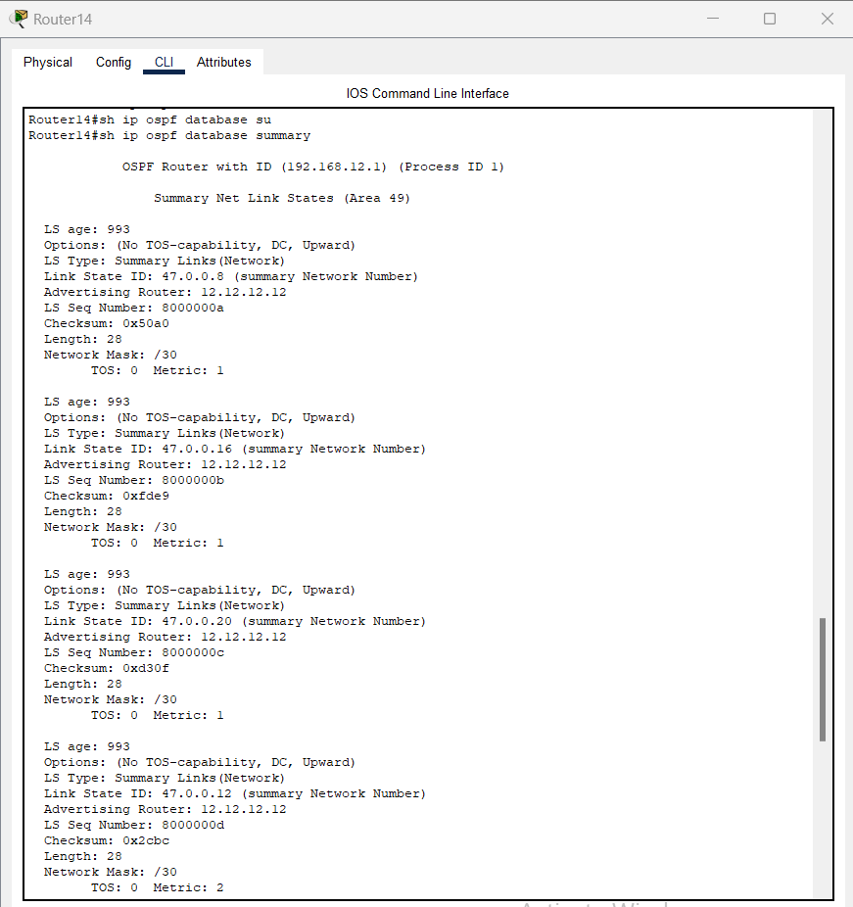

Figure 9 R14 Show ip ospf database summary

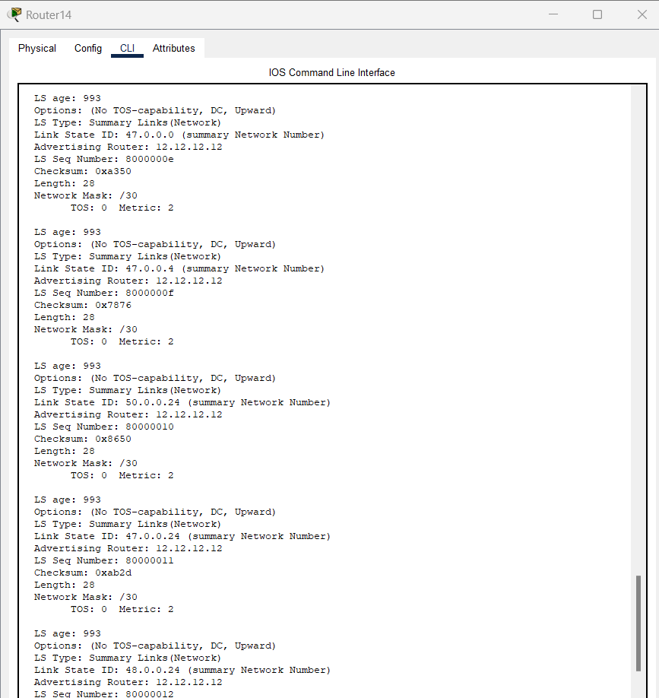

Figure 10 R14 Show ip ospf database summary

# R17 Show ip ospf database summary

Figure 11 R17 Show ip ospf database summary

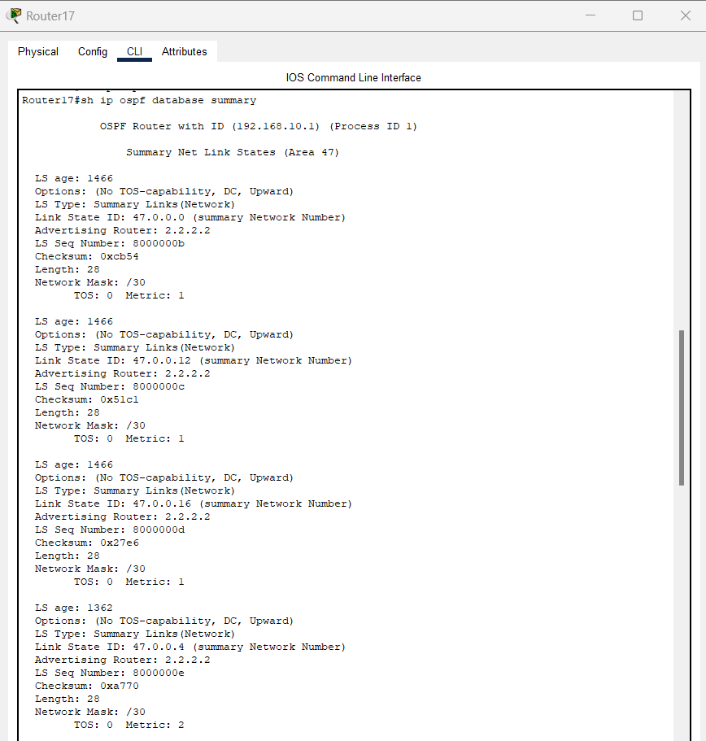

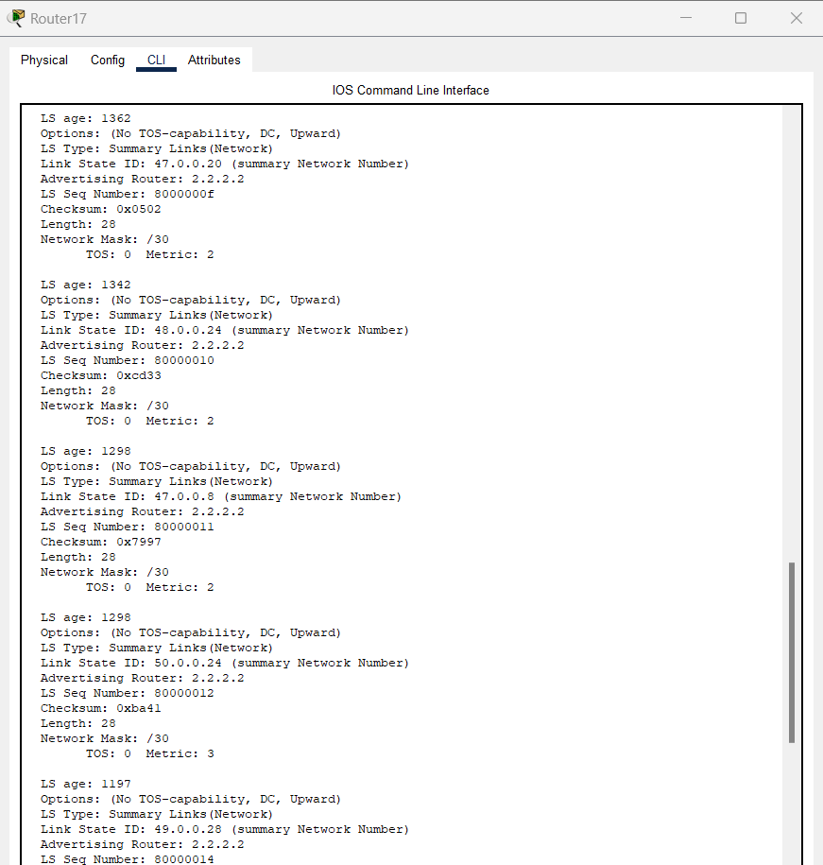

Figure 12 R17 Show ip ospf database summary

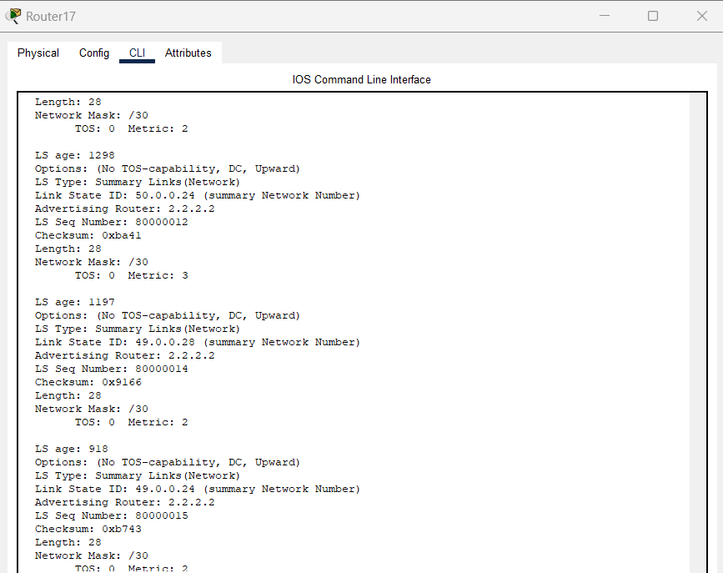

Figure 13 R17 Show ip ospf database summary

# R12 Show ip ospf database summary

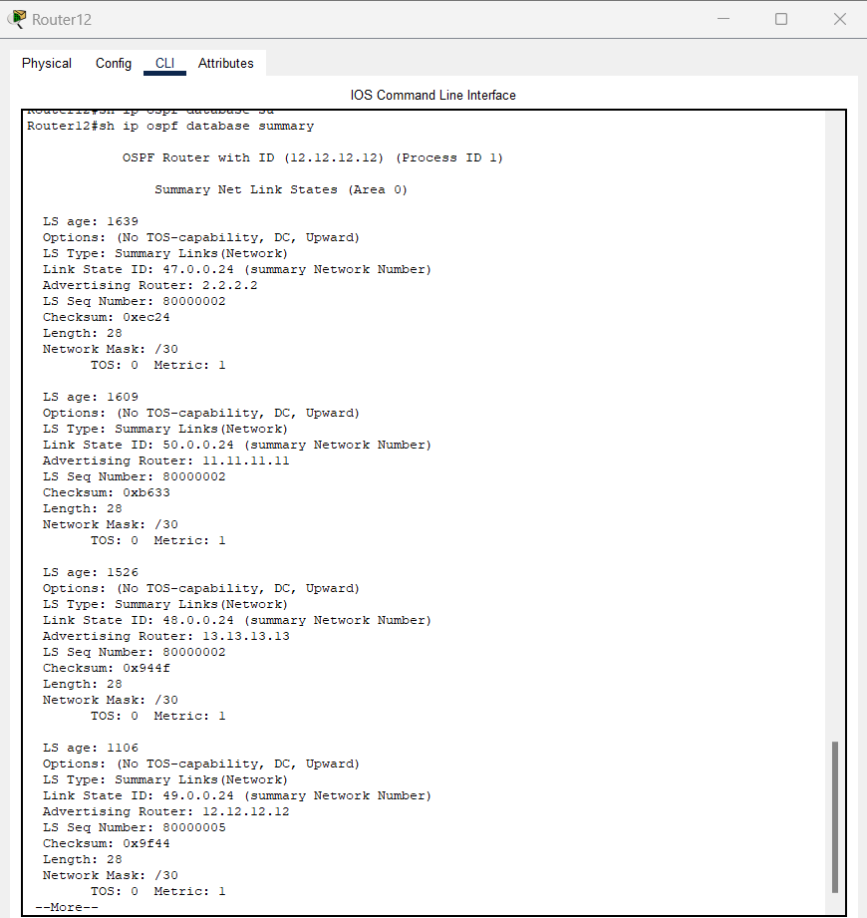

Figure 14 R12 Show ip ospf database summary

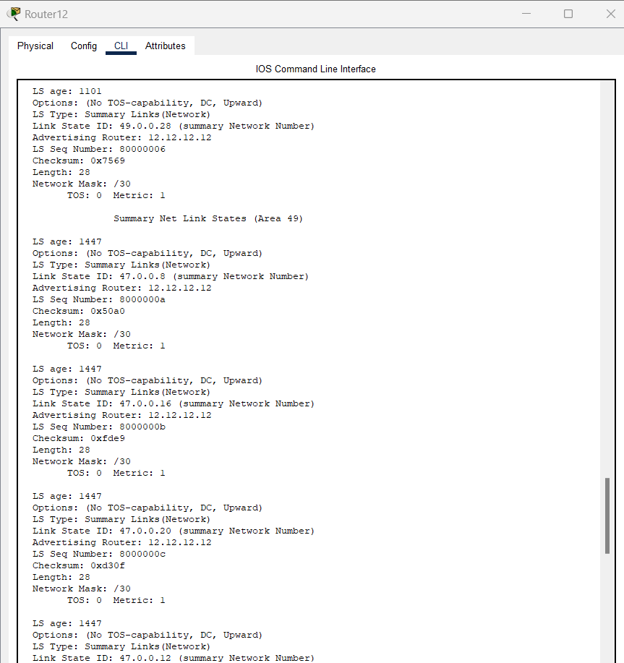

Figure 15 R12 Show ip ospf database summary

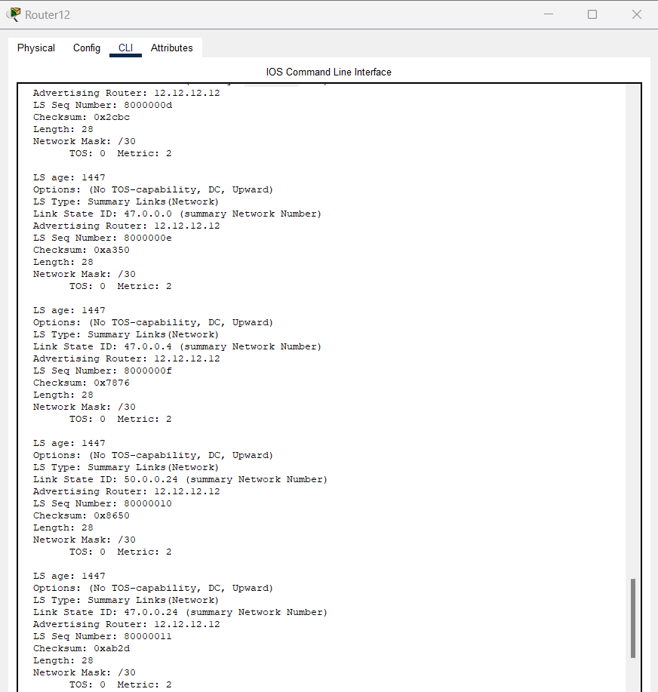

Figure 16 R12 Show ip ospf database summary

**7. Chose the area type carefully and write the reason why have chosen it for each area.**

Table 15 area names and addresses

|  |  |  |
| --- | --- | --- |
| Area 0 | | |
|  | | |
| Area 1 = Area 47 | | |
| 47.0.0.24/30 | 47.0.0.25 | 47.0.0.26 |
|  | | |
| Area 2 = Area 47+1 = Area 48 | | |
| 48.0.0.24/30 | 48.0.0.25 | 48.0.0.26 |
|  | | |
| Area 3 = Area x+2 = 47+2 = 49 | | |
| 49.0.0.24/30 | 49.0.0.25 | 49.0.0.26 |
| 49.0.0.28/30 | 49.0.0.29 | 49.0.0.30 |
|  | | |
| Area 4 = Area x+3 = 50 | | |
| 50.0.0.24/30 | 50.0.0.25 | 50.0.0.26 |

# cost from Router 14 to Router 17

**8. Show the cost from Router 14 to Router 17 and show all the paths. Define which one is shorter. Do Q.8 with the default reference B/W and see if you have to change it, Explain.**



Figure 17 topology

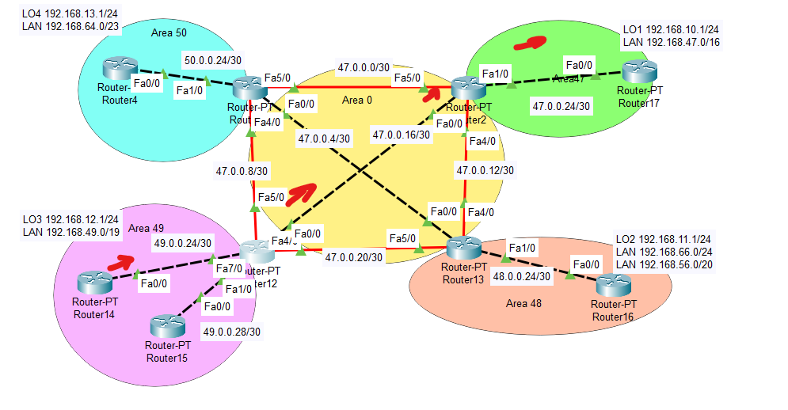

Figure 18 optimal path from R14 to R17

# show ip ospf interface brief

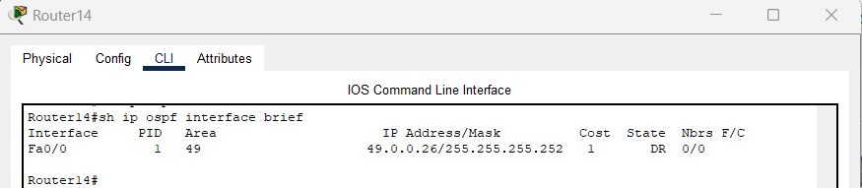

Figure 19 Router 14 show ip ospf interface brief

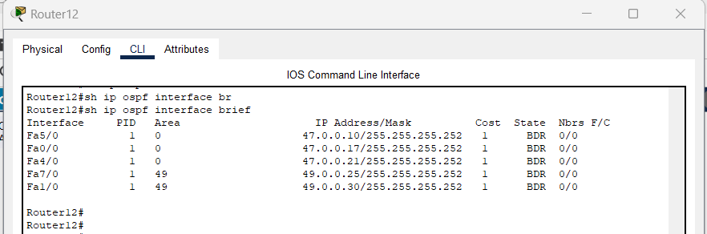

Figure 20 Router 12 show ip ospf interface brief

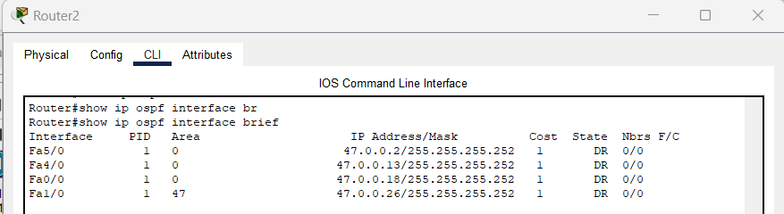

Figure 21 Router 2 show ip ospf interface brief

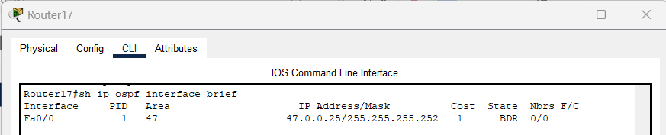

Figure 22 Router 17 show ip ospf interface brief

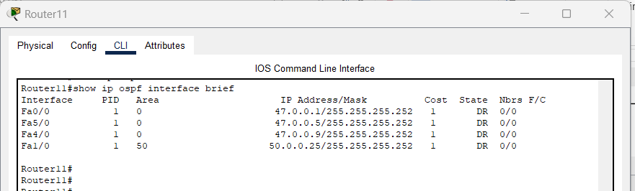

Figure 23 Router 11 show ip ospf interface brief

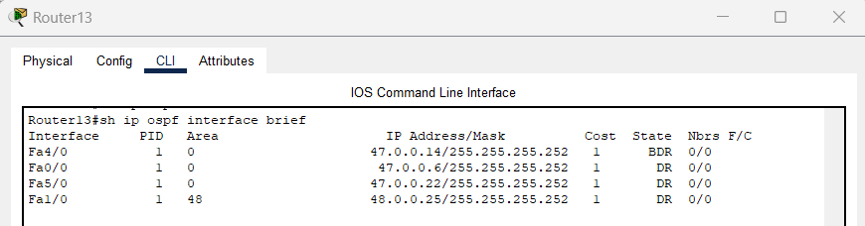

Figure 24 Router 13 show ip ospf interface brief

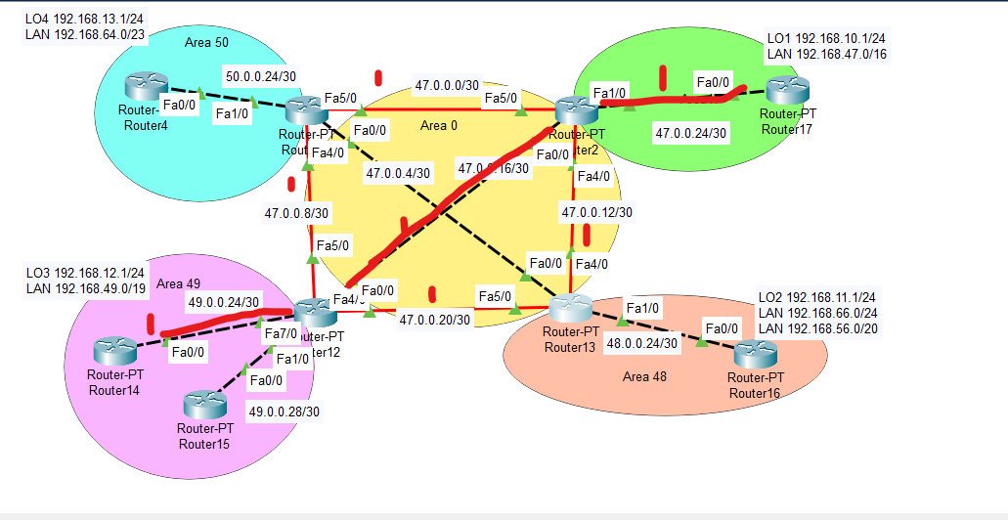

Figure 25 cost at each path

# Shortest path from Router 14 to Router 17

R14 > R12 > R2 > R17 is the shortest path

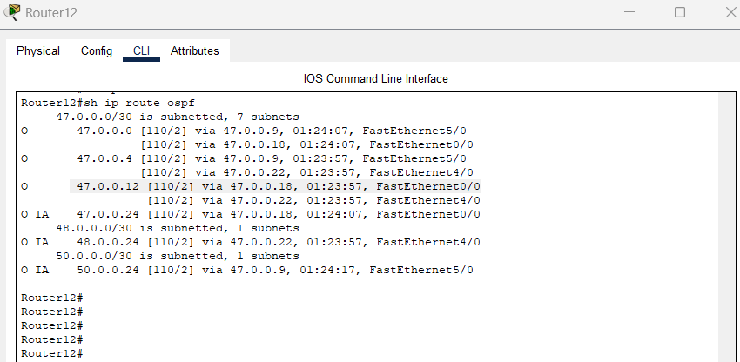

Figure 26 Router 12 show ip route ospf

# Cost from Router 14 to Router 17

8. Show the cost from Router 14 to Router 17 with the default reference B/W and see if you have to change it, Explain.

All interfaces are fastEthernet which are equal all over this topology



Figure 27 shortest path cost selection

R14 > R12 > R2 > R17 is the shortest path

This path remains the optimal path based on b/w

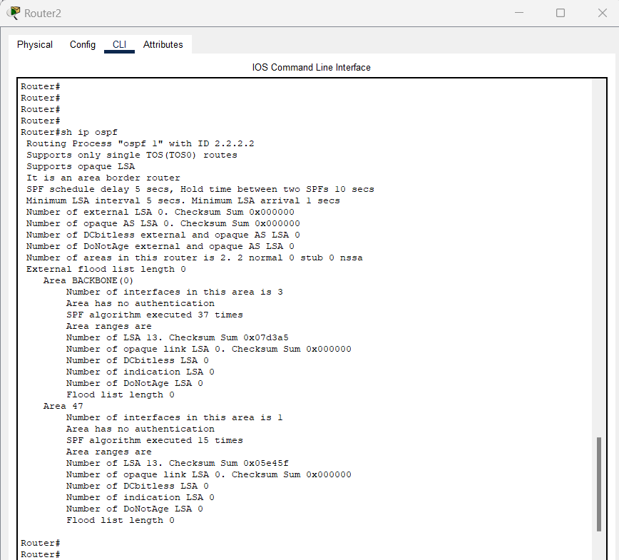

Figure 28 Router 2 show ip ospf

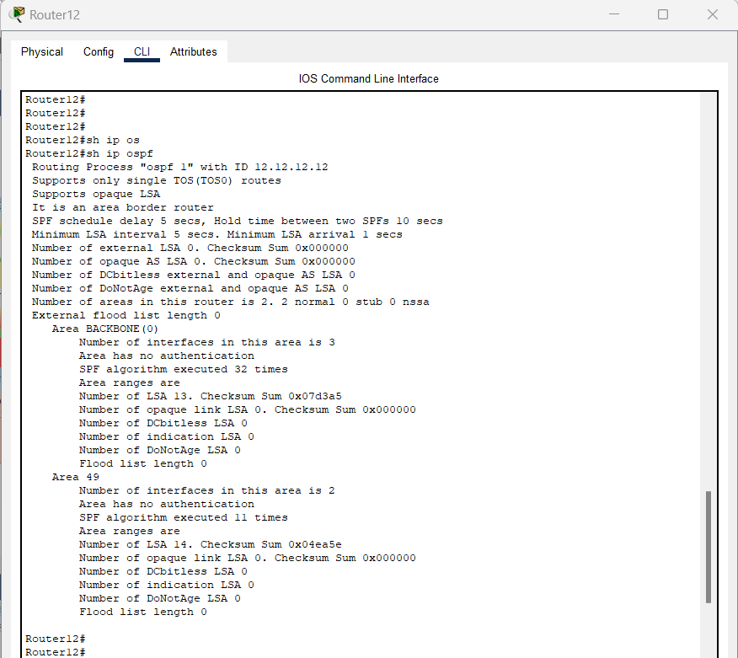

Figure 29 Router 12 show ip ospf

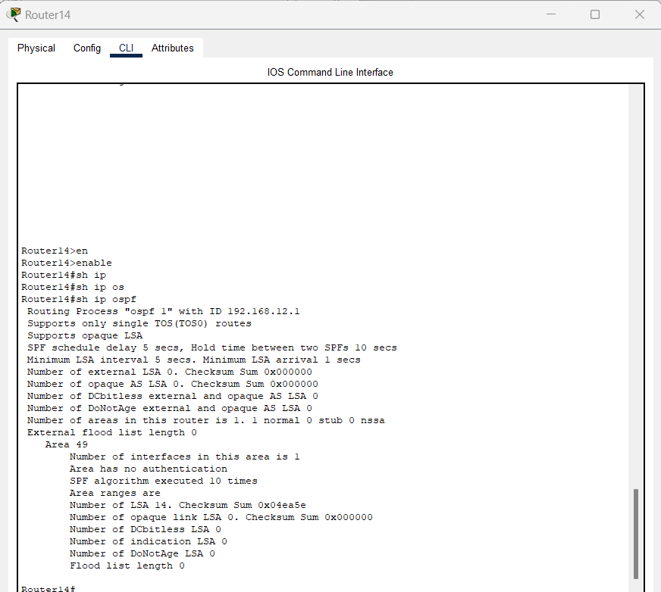

Figure 30 Router 14 show ip ospf

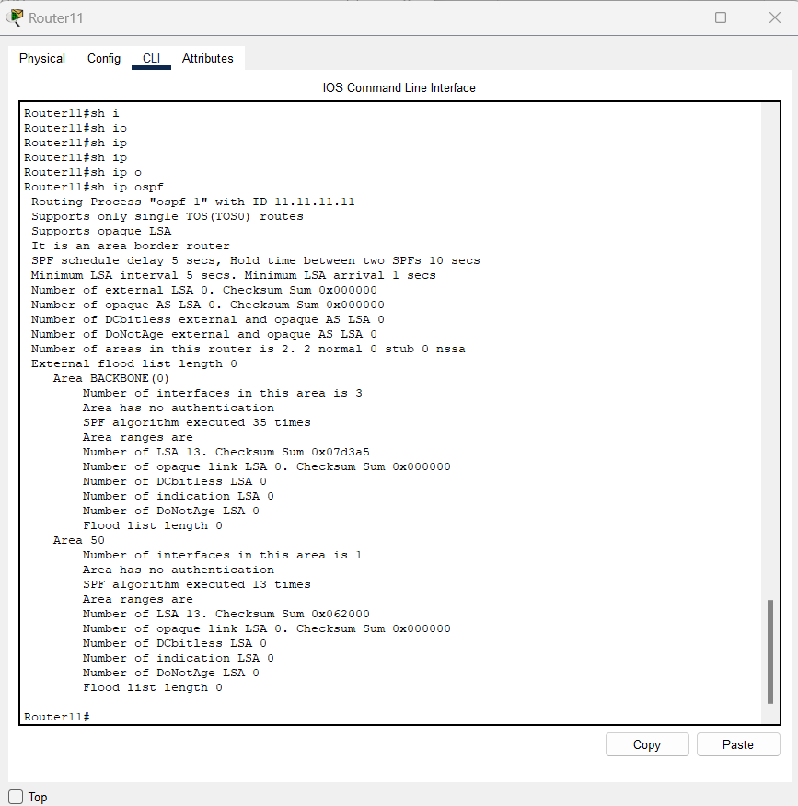

Figure 31 Router 11 show ip ospf

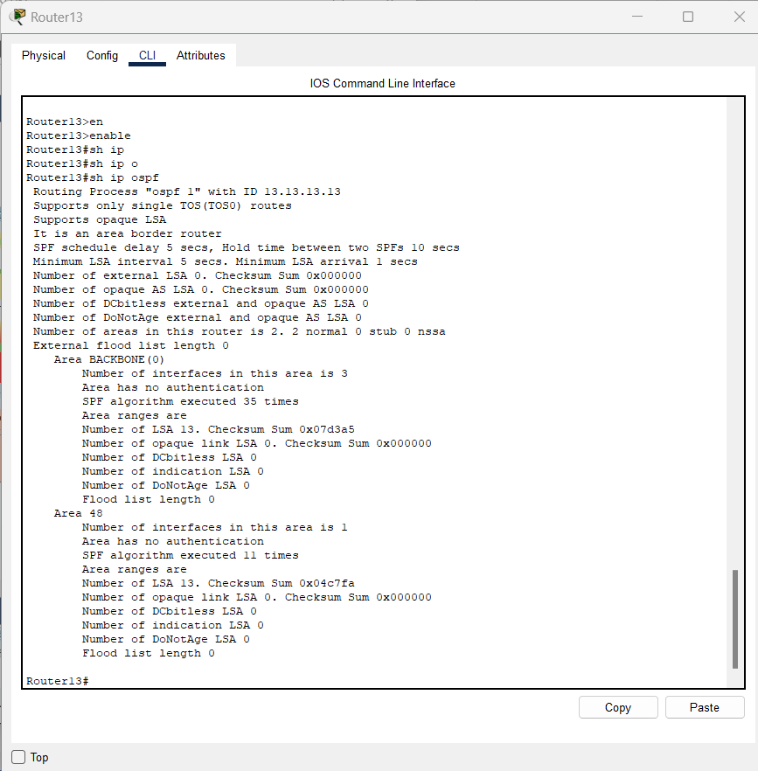

Figure 32 Router 13 show ip ospf

# Router 11

|  |
| --- |
| Router11#show running-config  Building configuration...  Current configuration : 1048 bytes  !  version 12.2  no service timestamps log datetime msec  no service timestamps debug datetime msec  no service password-encryption  !  hostname Router11  !  !  !  !  !  !  !  !  no ip cef  no ipv6 cef  !  !  !  !  !  !  !  !  !  !  !  !  !  !  !  !  !  !  interface FastEthernet0/0  ip address 47.0.0.1 255.255.255.252  duplex auto  speed auto  !  interface FastEthernet1/0  ip address 50.0.0.25 255.255.255.252  duplex auto  speed auto  !  interface Serial2/0  no ip address  clock rate 2000000  shutdown  !  interface Serial3/0  no ip address  clock rate 2000000  shutdown  !  interface FastEthernet4/0  ip address 47.0.0.9 255.255.255.252  !  interface FastEthernet5/0  ip address 47.0.0.5 255.255.255.252  !  interface Modem8/0  no ip address  !  interface Modem9/0  no ip address  !  router ospf 1  router-id 11.11.11.11  log-adjacency-changes  network 47.0.0.0 0.0.0.3 area 0  network 47.0.0.4 0.0.0.3 area 0  network 47.0.0.8 0.0.0.3 area 0  network 50.0.0.24 0.0.0.3 area 50  !  ip classless  !  ip flow-export version 9  !  !  !  !  !  !  !  !  line con 0  !  line aux 0  !  line vty 0 4  login  !  !  !  end  Router11# |

# Router 12

|  |
| --- |
| Router12#show running-config  Building configuration...  Current configuration : 1263 bytes  !  version 12.2  no service timestamps log datetime msec  no service timestamps debug datetime msec  no service password-encryption  !  hostname Router12  !  !  !  !  !  !  !  !  no ip cef  no ipv6 cef  !  !  !  !  !  !  !  !  !  !  !  !  !  !  !  !  !  !  interface FastEthernet0/0  ip address 47.0.0.17 255.255.255.252  duplex auto  speed auto  !  interface FastEthernet1/0  ip address 49.0.0.30 255.255.255.252  duplex auto  speed auto  !  interface Serial2/0  no ip address  clock rate 2000000  shutdown  !  interface Serial3/0  no ip address  clock rate 2000000  shutdown  !  interface FastEthernet4/0  ip address 47.0.0.21 255.255.255.252  !  interface FastEthernet5/0  ip address 47.0.0.10 255.255.255.252  !  interface FastEthernet6/0  no ip address  duplex auto  speed auto  shutdown  !  interface FastEthernet7/0  ip address 49.0.0.25 255.255.255.252  duplex auto  speed auto  !  interface FastEthernet9/0  no ip address  duplex auto  speed auto  shutdown  !  router ospf 1  router-id 12.12.12.12  log-adjacency-changes  network 47.0.0.8 0.0.0.3 area 0  network 47.0.0.16 0.0.0.3 area 0  network 47.0.0.20 0.0.0.3 area 0  network 49.0.0.24 0.0.0.3 area 49  network 49.0.0.28 0.0.0.3 area 49  !  ip classless  !  ip flow-export version 9  !  !  !  !  !  !  !  !  line con 0  !  line aux 0  !  line vty 0 4  login  !  !  !  end  Router12# |

# Router 2

|  |
| --- |
| Router#show running-config  Building configuration...  Current configuration : 1122 bytes  !  version 12.2  no service timestamps log datetime msec  no service timestamps debug datetime msec  no service password-encryption  !  hostname Router  !  !  !  !  !  !  !  !  no ip cef  no ipv6 cef  !  !  !  !  !  !  !  !  !  !  !  !  !  !  !  !  !  !  interface FastEthernet0/0  ip address 47.0.0.18 255.255.255.252  duplex auto  speed auto  !  interface FastEthernet1/0  ip address 47.0.0.26 255.255.255.252  duplex auto  speed auto  !  interface Serial2/0  no ip address  clock rate 2000000  shutdown  !  interface Serial3/0  no ip address  clock rate 2000000  shutdown  !  interface FastEthernet4/0  ip address 47.0.0.13 255.255.255.252  !  interface FastEthernet5/0  ip address 47.0.0.2 255.255.255.252  !  interface Ethernet8/0  no ip address  duplex auto  speed auto  shutdown  !  interface Ethernet9/0  no ip address  duplex auto  speed auto  shutdown  !  router ospf 1  router-id 2.2.2.2  log-adjacency-changes  network 47.0.0.0 0.0.0.3 area 0  network 47.0.0.12 0.0.0.3 area 0  network 47.0.0.16 0.0.0.3 area 0  network 47.0.0.24 0.0.0.3 area 47  !  ip classless  !  ip flow-export version 9  !  !  !  !  !  !  !  !  line con 0  !  line aux 0  !  line vty 0 4  login  !  !  !  end  Router# |

# Router 13

|  |
| --- |
| Router13#show running-config  Building configuration...  Current configuration : 1128 bytes  !  version 12.2  no service timestamps log datetime msec  no service timestamps debug datetime msec  no service password-encryption  !  hostname Router13  !  !  !  !  !  !  !  !  no ip cef  no ipv6 cef  !  !  !  !  !  !  !  !  !  !  !  !  !  !  !  !  !  !  interface FastEthernet0/0  ip address 47.0.0.6 255.255.255.252  duplex auto  speed auto  !  interface FastEthernet1/0  ip address 48.0.0.25 255.255.255.252  duplex auto  speed auto  !  interface Serial2/0  no ip address  clock rate 2000000  shutdown  !  interface Serial3/0  no ip address  clock rate 2000000  shutdown  !  interface FastEthernet4/0  ip address 47.0.0.14 255.255.255.252  !  interface FastEthernet5/0  ip address 47.0.0.22 255.255.255.252  !  interface Ethernet8/0  no ip address  duplex auto  speed auto  shutdown  !  interface Ethernet9/0  no ip address  duplex auto  speed auto  shutdown  !  router ospf 1  router-id 13.13.13.13  log-adjacency-changes  network 47.0.0.12 0.0.0.3 area 0  network 47.0.0.4 0.0.0.3 area 0  network 47.0.0.20 0.0.0.3 area 0  network 48.0.0.24 0.0.0.3 area 48  !  ip classless  !  ip flow-export version 9  !  !  !  !  !  !  !  !  line con 0  !  line aux 0  !  line vty 0 4  login  !  !  !  end  Router13# |

# Router 4

|  |
| --- |
| Router#sh run  Building configuration...  Current configuration : 960 bytes  !  version 12.2  no service timestamps log datetime msec  no service timestamps debug datetime msec  no service password-encryption  !  hostname Router  !  !  !  !  !  ip dhcp pool router4  network 192.168.48.0 255.255.254.0  default-router 192.168.64.1  !  !  !  ip cef  no ipv6 cef  !  !  !  !  !  !  !  !  !  !  !  !  !  !  !  !  !  !  interface Loopback4  ip address 192.168.13.1 255.255.255.0  !  interface FastEthernet0/0  ip address 50.0.0.26 255.255.255.252  duplex auto  speed auto  !  interface FastEthernet1/0  no ip address  duplex auto  speed auto  shutdown  !  interface Serial2/0  no ip address  clock rate 2000000  shutdown  !  interface Serial3/0  no ip address  clock rate 2000000  shutdown  !  interface FastEthernet4/0  no ip address  shutdown  !  interface FastEthernet5/0  no ip address  shutdown  !  router ospf 1  log-adjacency-changes  network 50.0.0.24 0.0.0.3 area 50  !  ip classless  !  ip flow-export version 9  !  !  !  !  !  !  !  !  line con 0  !  line aux 0  !  line vty 0 4  login  !  !  !  end  Router# |

# Router 17

|  |
| --- |
| Router17#sh run  Building configuration...  Current configuration : 959 bytes  !  version 12.2  no service timestamps log datetime msec  no service timestamps debug datetime msec  no service password-encryption  !  hostname Router17  !  !  !  !  !  ip dhcp pool router17  network 192.168.0.0 255.255.0.0  default-router 192.168.0.1  !  !  !  ip cef  no ipv6 cef  !  !  !  !  !  !  !  !  !  !  !  !  !  !  !  !  !  !  interface Loopback1  ip address 192.168.10.1 255.255.255.0  !  interface FastEthernet0/0  ip address 47.0.0.25 255.255.255.252  duplex auto  speed auto  !  interface FastEthernet1/0  no ip address  duplex auto  speed auto  shutdown  !  interface Serial2/0  no ip address  clock rate 2000000  shutdown  !  interface Serial3/0  no ip address  clock rate 2000000  shutdown  !  interface FastEthernet4/0  no ip address  shutdown  !  interface FastEthernet5/0  no ip address  shutdown  !  router ospf 1  log-adjacency-changes  network 47.0.0.24 0.0.0.3 area 47  !  ip classless  !  ip flow-export version 9  !  !  !  !  !  !  !  !  line con 0  !  line aux 0  !  line vty 0 4  login  !  !  !  end  Router17# |

# Router 16

|  |
| --- |
| Router16#sh run  Building configuration...  Current configuration : 1052 bytes  !  version 12.2  no service timestamps log datetime msec  no service timestamps debug datetime msec  no service password-encryption  !  hostname Router16  !  !  !  !  !  ip dhcp pool router16  network 192.168.66.0 255.255.255.0  default-router 192.168.66.1  ip dhcp pool router16-2  network 192.168.48.0 255.255.240.0  default-router 192.168.16.1  !  !  !  ip cef  no ipv6 cef  !  !  !  !  !  !  !  !  !  !  !  !  !  !  !  !  !  !  interface Loopback2  ip address 192.168.11.1 255.255.255.0  !  interface FastEthernet0/0  ip address 48.0.0.26 255.255.255.252  duplex auto  speed auto  !  interface FastEthernet1/0  no ip address  duplex auto  speed auto  shutdown  !  interface Serial2/0  no ip address  clock rate 2000000  shutdown  !  interface Serial3/0  no ip address  clock rate 2000000  shutdown  !  interface FastEthernet4/0  no ip address  shutdown  !  interface FastEthernet5/0  no ip address  shutdown  !  router ospf 1  log-adjacency-changes  network 48.0.0.24 0.0.0.3 area 48  !  ip classless  !  ip flow-export version 9  !  !  !  !  !  !  !  !  line con 0  !  line aux 0  !  line vty 0 4  login  !  !  !  end  Router16# |

# Router 15

|  |
| --- |
| Router15#sh run  Building configuration...  Current configuration : 815 bytes  !  version 12.2  no service timestamps log datetime msec  no service timestamps debug datetime msec  no service password-encryption  !  hostname Router15  !  !  !  !  !  !  !  !  ip cef  no ipv6 cef  !  !  !  !  !  !  !  !  !  !  !  !  !  !  !  !  !  !  interface FastEthernet0/0  ip address 49.0.0.29 255.255.255.252  duplex auto  speed auto  !  interface FastEthernet1/0  no ip address  duplex auto  speed auto  shutdown  !  interface Serial2/0  no ip address  clock rate 2000000  shutdown  !  interface Serial3/0  no ip address  clock rate 2000000  shutdown  !  interface FastEthernet4/0  no ip address  shutdown  !  interface FastEthernet5/0  no ip address  shutdown  !  router ospf 1  log-adjacency-changes  network 49.0.0.28 0.0.0.3 area 49  !  ip classless  !  ip flow-export version 9  !  !  !  !  !  !  !  !  line con 0  !  line aux 0  !  line vty 0 4  login  !  !  !  end  Router15# |

# Router 14

|  |
| --- |
| Router14#sh run  Router14#sh running-config  Building configuration...  Current configuration : 1052 bytes  !  version 12.2  no service timestamps log datetime msec  no service timestamps debug datetime msec  no service password-encryption  !  hostname Router14  !  !  !  !  !  ip dhcp pool router14  network 192.168.32.0 255.255.224.0  default-router 192.168.32.1  ip dhcp pool router14-2  network 192.168.31.0 255.255.255.0  default-router 192.168.31.1  !  !  !  ip cef  no ipv6 cef  !  !  !  !  !  !  !  !  !  !  !  !  !  !  !  !  !  !  interface Loopback3  ip address 192.168.12.1 255.255.255.0  !  interface FastEthernet0/0  ip address 49.0.0.26 255.255.255.252  duplex auto  speed auto  !  interface FastEthernet1/0  no ip address  duplex auto  speed auto  shutdown  !  interface Serial2/0  no ip address  clock rate 2000000  shutdown  !  interface Serial3/0  no ip address  clock rate 2000000  shutdown  !  interface FastEthernet4/0  no ip address  shutdown  !  interface FastEthernet5/0  no ip address  shutdown  !  router ospf 1  log-adjacency-changes  network 49.0.0.24 0.0.0.3 area 49  !  ip classless  !  ip flow-export version 9  !  !  !  !  !  !  !  !  line con 0  !  line aux 0  !  line vty 0 4  login  !  !  !  end  Router14# |